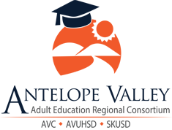

AVAERC Three-Year Plan
2019-2022

Approved for submission by the AVAERC Membership:

Table of Contents

Section 1: Consortium Information

Section 2: Comprehensive Regional Three-Year Plan

2.1 Executive Summary

2.2 Pre-Planning Assessment

Table 1. Regional Service Providers

Table 2. Funding for Adult Education Programs and Services

2.3 Community Needs and Customers

2.4 Identifying Goals and Strategies

Figure 1. Logic Model

Table 3. Progress Indicators

2.5 Piloting and Implementation

Section 1: Consortium Information

Consortium Name: Antelope Valley Adult Education Regional Consortium

Primary Contact Name: Dr. Steven Radford

Title: Regional Director – College/Career Preparation and Adult Education

Phone: (661) 483-2302

Email: sradford@avhsd.org

Section 2: Comprehensive Regional Plan

2.1 Executive Summary
The Antelope Valley Adult Education Regional Consortium (AVAERC) region includes 40 percent of the land mass of Los Angeles County, as well as a small section in the southeastern part of Kern County. The geography is characterized by a broad, flat, high desert valley that merges into the San Gabriel Mountains. These mountains serve as a physical divider between the Antelope Valley and the Los Angeles Basin. The nearest community colleges in other regions are at least 50 miles away, making the commuting time to these locations over an hour in length.
The AVAERC region has a service area of 1,945 square miles. Within this service area, the two main cities are Lancaster (pop. 161,806), where the only college of the District is currently located, and Palmdale (pop. 169,514), where a second campus center is located. The rest of the population of the region is dispersed somewhat equally, with a total population of approximately 450,000 people throughout the region. That number is expected to rise to nearly 500,000 by the year 2021.
The AVAERC began with three members, Antelope Valley College, Antelope Valley Union High School District, and Southern Kern Unified School District. This year, SKUSD has made the decision to leave the consortium, leaving AVC and AVUHSD as the two voting members.
While the two members of the consortium took the lead, there was a concerted effort to collaborate with and involve stakeholders throughout the region, in developing this three-year plan. This plan will serve as the Consortium’s blueprint for adult education in the region moving forward. Through the creation of community partnerships, the Consortium continues to work towards creating a plan that will meet the needs of all stakeholders in the region.
The last three years have seen the Consortium lay the foundation for growing current, as well as developing new, programs. With the addition of a new CTE facility, the consortium now has the space needed to increase enrollment across all areas of adult education.
Through a series of community forums, the Consortium was able to identify the three greatest priorities of the region.
- Career Technical Education and Apprenticeships – The work completed at the community forums overwhelmingly showed CTE/Apprenticeships as the priority of the region.
- English as a Second Language – The 2010 census showed that 30-40% of the region’s population is classified as ESL. While we currently offer a substantial amount of ESL support, the consortium recognizes the need for residents of the region to speak and understand English in order to be competitive in the workforce as a top priority.
- Adult Basic Education – According to the 2018 GAVEA Economic Roundtable Report, approximately 20% of the residents of the region have less than a high school diploma. The consortium recognizes the correlation between education and workforce participation, and feels it is necessary to make basic education available to all of the residents of the region.
All areas of adult education have the need for greater support services. The consortium recognizes and supports the need for additional counseling and clerical support in all program areas. These positions are vital to the success of the CAEP mission. Moving forward, the AVAERC would like to have more counselors/transition specialists involved in transitioning students to postsecondary pathways.
Even with the addition of the CTE facility, the AVAERC recognizes the need for additional physical space as we continue to expand programs. With the departure of SKUSD from adult education, there is a need for classes in the northern most part of the region. There is also a need for improvements to the current facilities at AVUHSD. Both of their buildings are in need of repair and improvements.
The main focus for AVAERC will be to continue expanding services to reach as many members of the region as possible. Additionally, there will be a focus on improving counseling services for all adult education students.

2.2 Pre-Planning Assessment
To prepare for drafting the Three-Year Plan, AVAERC engaged in a series of activities:
- Members used the CAEP Three-Year Planning Self-Assessment Tool to assist in the process of planning for this report.
- Meetings with member leads were held to identify assess needs of the consortium.
- Staff and student surveys were given to better understand the needs of the school community.
- Members sent representatives to various three-year plan trainings throughout the year.
- Los Angeles County Labor Market information was used to identify industry trends and inform educational program offerings.
- Data from the Greater Antelope Valley Economic Alliance (GAVEA) Round Table Report was analyzed to better understand the demographics of the communities being served.
- The CAEP Consortium Factsheet was used to gather data for the three-year plan.
- Community forums were held to gather qualitative data on the types of programs needed in the region.

Table 1: Regional Services Provided

Provider  Name | Provider Type | Address or  location(s)  where AE  services are  provided | Program Areas |  |  |  |  |  |  |  | If other, provide a  brief description of  ABE ASE ESL CTE AWD WR PA ACS services provided
 |  |  | ABE | ASE | ESL | CTE | AWD | WR | PA | ACS
Antelope Valley Union High School District | K-Adult | 44811 N. Sierra Hwy, Lancaster CA 93534 | X | X | X | X | X
Southern Kern Unified School District | K-Adult | 2601 Rosamond Blvd., Rosamond, CA 93560 |  | X | X | X
Antelope Valley College | College | 3041 West Ave K, Lancaster, CA 93536 |  |  | X | X
GAIN (Greater Avenues of Independence) | Social Services | 1050 E Palmdale Blvd, Palmdale, CA 93550 | X | X |  | X
GROW (General Relief Opportunities for Work) | Social Services | 337 E Ave K 10, Lancaster, CA 93535 | X
DPSS (Dept. of Public Social Services) | Social Services | 349-B E Ave K 6 K-6, Lancaster, CA 93535
The Department of Rehabilitation | Social Services | 43301 Division St # 204A, Lancaster, CA 93535
CCRC (Child Care Resource Center) | Social Services | 250 Grand Cypress Ave, Palmdale, CA 93551
Department of Veterans Affairs | Social Services | 38925 Trade Center Dr, Palmdale, CA 93551
CalWORKs offices | Social Services | 4680 San Fernando Rd, Glendale, CA 91204
Tribal TANF (Temporary Assistance to Needy Families) | Social Services | 460 W Palmdale Blvd, Palmdale, CA 93551
EDD Work-Source CA Antelope Valley One Stop Career Center office. | Workforce Development | 1420 W Ave I, Lancaster, CA 93534 | X | X |  | X |  | X
Antelope Valley WorkSource Center | Workforce Development | 1420 W Ave I, Lancaster, CA 93534 |  |  |  | X |  | X
GAVEA (Antelope Valley Greater Economic Alliance) | Workforce Development | SCT, 3041 W Ave K #125, Lancaster, CA 93536
AVBOT (Antelope Valley Board of Trade) | Workforce Development | 41301 12th St W, Palmdale, CA 93551
City of Lancaster | Probation Education | 44933 Fern Avenue, Lancaster, CA 93534 | X | X
South Valley WorkSource Center | Workforce Development | 38510 Sierra Hwy, Palmdale, CA 93550 |  |  |  | X

Table 2: Funding for Adult Education Programs and Services

Funding Source | Funding Estimates FY2019-20 | Funding Estimates FY2020-21 | Funding Estimates FY2021-22
AEP | $4,097,108 | $4,097,108 | $4,097,108
CalWORKs | $350,000 | $350,000 | $350,000
WIOA II | $550,000 | $550,000 | $550,000
Total | $4,997,108 | $4,997,108 | $4,997,108

2.3 Community Need and Customers
To assess the needs of the Antelope Valley, AVAERC reviewed data from multiple sources to gain a better understanding of the needs, customers, and demographics of the communities served by the consortium.

- Past community input:
AVAERC reviewed data from past community forums. This data gave insight into the historical context of the work the consortium has accomplished over the past five years, and what still remains to be needed.

- Current community input:
AVAERC reviewed data from current community forums. Members of AVAERC participate in a variety of community organizations such as GAVEA (Greater Antelope Valley Economic Alliance), AVBOT (Antelope Valley Board of Trade), and advisory boards for the various programs of the consortium. During these meetings, data is gathered both formally and informally.

- Labor market data:
The AVAERC uses Labor Market Information to inform decisions concerning programs and community needs.

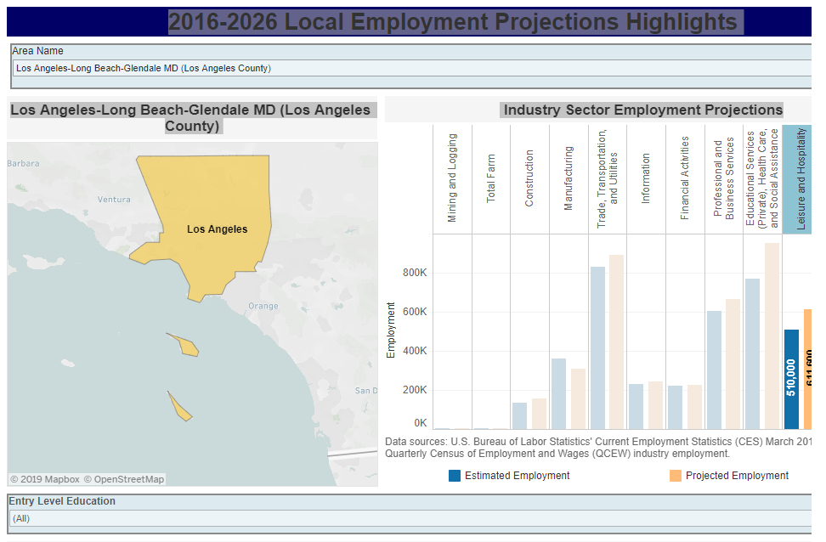
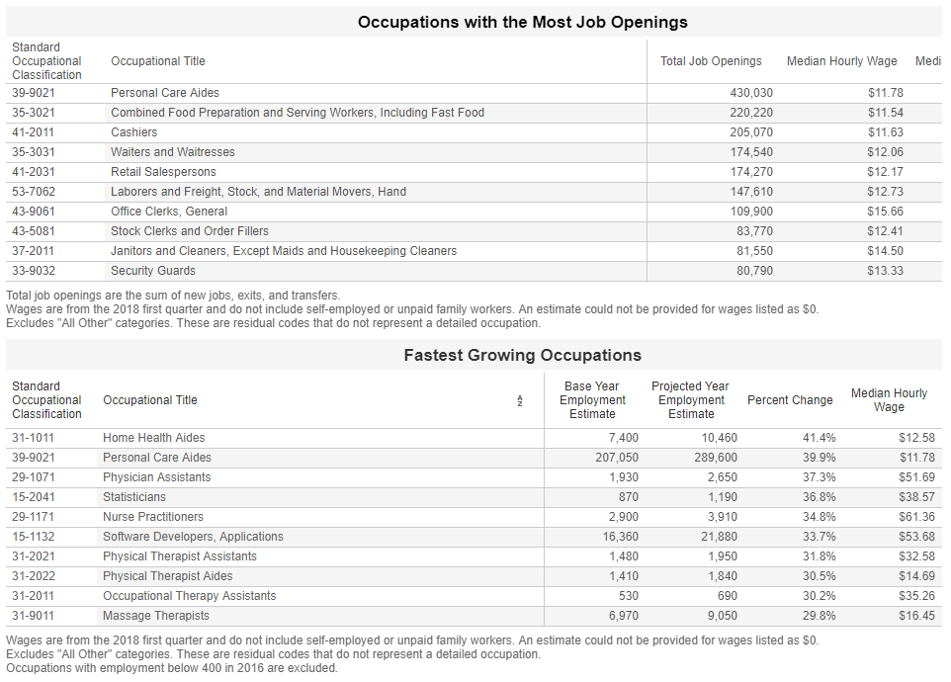
- CAEP fact sheet:
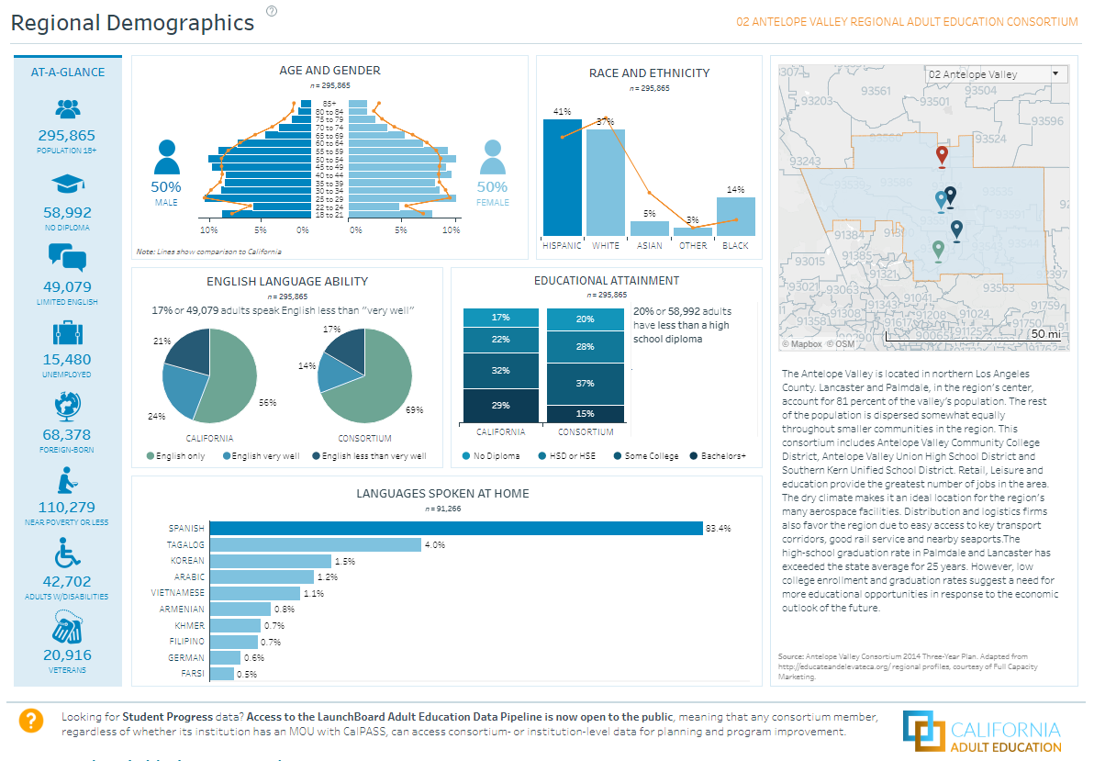

- Staff and Student surveys:
AVAE is currently going through the WASC process. During the self-study process, students and staff members were surveyed on specific aspects of the adult education programs. Information from these surveys was used to help guide decision making for the consortium.

- CAEP Three-Year Planning Self-Assessment Tool:
The CAEP Three-Year Planning Self-Assessment Tool was used by the AVAERC as a means of better understanding the current strengths and opportunities of the Consortium.

2.4 Identifying Goals and Strategies
Figure 1: Logic Model
Goal Area | Strategy | Output | Short-Term Outcomes (12-Month) | Intermediate Outcomes (1-3 Years) | Long-Term Outcomes (3-5 Years)
We will focus on the following AB104  Objectives: | We will  accomplish the following  activities: | These activities  will produce  the following  evidence or  service  delivery: | If accomplished, these activities will lead to the following outcomes in the next year | If accomplished,  these activities will lead to the following outcomes in 1-3  years | If accomplished,  these activities  will lead to the  following  outcomes in 3-5 years
Seamless Transitions | Increase  number of  ABE/ASE/ESL/CTE  courses based on  community need  and enrollment demand. | More opportunities for student participation in consortium programs. | Greater enrollment in consortium programs. | Greater completion of consortium programs. | Greater  number of  students  transitioning  to  postsecondary  programs and  the workforce
 | Hire a  transition  counselor to  facilitate a  greater level of  transition from  Adult Schools into  Antelope Valley  College. | Greater level  of wraparound  services for all  students  served by the  Consortium | Hire a full-time  Counselor. | Evaluate need and  adjust employment  status. | Evaluate need and  adjust employment  status.
 | Develop  articulation  agreements  between Adult  Schools and  Antelope Valley  College. | Greater  transition of  students to  postsecondary credit  programs | Assist college with implementation of AB705 | See pathways being developed and aligned to AVC courses of study | See pathways for all relevant courses of study.
Gaps in Services | Expand and improve outreach and marketing to target identified populations | Increased enrollment in consortium programs. | Increased social media presence; Enhanced print marketing campaign; Ongoing radio PSAs | Increased social media presence; Enhanced print marketing campaign; Ongoing radio PSAs | Increased social media presence; Enhanced print marketing campaign; Ongoing radio PSAs
 | Educate the community about what the Consortium does | Stronger and more established community partnerships | Regularly scheduled Community Stakeholder meetings | Ongoing engagement with business, faith-based, governmental, and non-profit stakeholders | Formation of an ongoing Advisory Council for AVAERC
 | Expanded service hours and classes offered when and where students can attend them. | Increased accessibility to students. | Increased offerings in non-traditional locations. | Increase the amount of adult education classes being offered across the entire region. | Increased enrollment; Increased program completions.
 | Infused digital literacy and technology instruction into curriculum. | Students will have a deeper knowledge of the content area through use of technology. | Professional Development for all faculty/staff on embedding DL into instructional models. | Technology instruction pervasive across all classes. | Technology instruction pervasive across all classes.
 | Offer additional CTE classes and certificates (short- and long-term) across a range of industry sectors. | Wage increases and higher job placement rates and mobility as demonstrated through DIR and MIS reporting. | Increased offerings across all industry sectors, specifically in the trades. | Increased offerings across all industry sectors, specifically in the trades. | Increased offerings across all industry sectors, specifically in the trades.
 | Increase  student  participation in  work-based  learning activities | Greater  transition to  the workforce  and job  promotion | Greater hands on experience before students begin OTJ Training. | Greater hands on experience before students begin OTJ Training. | Greater hands on experience before students begin OTJ Training.
 | Hire a  transition  counselor to  facilitate a  greater level of  transition from  Adult Schools into  Antelope Valley  College. | Greater level  of wraparound  services for all  students  served by the  Consortium | Hire a full-time  Counselor. | Evaluate need and  adjust employment  status. | Evaluate need and  adjust employment  status.
Student Acceleration | Increase enrollment, graduation rates, and transitions to postsecondary and/or employment | Increased performance outcomes | 5% increase in transitions validated through DIR and MIS reports | 10% increase in transitions validated through DIR and MIS reports | 15% increase in transitions validated through DIR and MIS reports
 | Improve information available to students about career pathways, career opportunities, and alignment between course offerings at the Adult Schools and the Community Colleges | Hire a  transition  counselor to  facilitate a  greater level of  transition from  Adult Schools into  Antelope Valley  College. | Develop a Career Pathway Matrix | Reevaluate program success and create next-steps | Reevaluate program success and create next-steps
 | Establish Integrated Education and Training program | Greater number of students enrolled in ESL and CTE classes concurrently. | Greater number of ESL students earning CTE certificates. | Greater number of ESL students gaining employment and earning higher wages. | Greater number of ESL students gaining employment and earning higher wages.
 | Increase  offerings of postsecondary  CTE  credential  programs (short-term  and long-term). | More career options for more students. | Greater number of students earning CTE certifications. | Greater number of students gaining employment and earning higher wages. | Greater number of students gaining employment and earning higher wages.
Professional Development | Develop an  ongoing  professional  development plan. | Faculty/Staff will have access to adult education specific professional development. | Faculty/Staff will  attend state and  national conferences. | Ongoing  participation in  professional  development  opportunities by Faculty and  Staff | Ongoing  participation in  professional  development  opportunities by Faculty and  Staff
 | Program-specific  professional  development | Greater depth  of knowledge  for HiSET,  GED, Aztec,  Burlington, PEAK, and  CASAS | Increased level of  data-driven  placement and  instruction | Increased level of  data-driven  placement and  instruction | Increased level of  data-driven  placement and  instruction
Leveraging Resources | Stronger engagement with the Workforce Development Board. | Develop policies and procedures for cross-agency referrals | Increase in labor force participation; increased job promotions; increased wages | Established partnerships with the Workforce Development Board | Established partnerships with the Workforce Development Board
 | Student internships and work-based learning opportunities established with local businesses | Greater transitions of students to the workplace | Identified career pathways that support high growth industries identified by the Workforce Development Board | Established placement of students in work-based learning opportunities | Established placement of students in work-based learning opportunities
 | American Job Center representative and member representative spend time at each site. | Career and job placement liaison | Establish MOU with Workforce Development Board | Dedicated American Job Center time. | Dedicated American Job Center time.
 | Develop a reduced sentencing program in partnership with the City of Lancaster and LA County Court. | Reduced  recidivism; Greater number of people in HSE programs. | Pilot program | Fully  implemented  reduced sentencing  program | Fully  implemented  reduced sentencing  program
 | Establish a  referral process  with county  agencies. | Provide  greater access  to services  needed by  adult  education  students | Conduct regular  meetings with key  agencies | Have an established  referral process in  place | Have an established  referral process in  place

Table 3: Progress Indicators
Seamless Transitions
Demonstrable increase in transitions to postsecondary as evidenced through Member District DIRs and MIS reports.
Demonstrable increase in transitions to the workforce as evidenced through Member District DIRs and LMI data.
Gaps in Services
Increased number of courses and subjects being offered by Member Districts.
Increased number of community partners.
Student Acceleration
Developed and implemented articulation agreements between K-12 Adult Schools and the Community College.
Fully implemented Distance Learning Implementation Manual. - Fully implemented integrated education and training programs.
Professional Development
Thoroughly developed plan for professional development targeting the specific needs of adult education in the region.
Participation by all faculty and staff from all member districts in professional development opportunities.
Leveraging Resources
Expanded service offerings in partnership with the Workforce Development Board and local businesses.
Placement of students in internships and work-based learning opportunities.

2.5 Piloting and Implementation

To meet the goals identified above, the following strategies will be implemented:

1. To increase the number of offerings, and students served, the consortium will seek to add additional facilities to house all areas of adult education. Additionally, an effort will be made to upgrade, and modernize current facilities so that all adult education students are being served at the highest level possible.

2. To assist students in transitioning to post-secondary programs, the consortium will seek to hire additional counselors and transitional specialist to provide a variety of wraparound services. These services will include academic, career, and social/emotional counseling for all adult education students.

3. To increase community awareness of adult education programs, the consortium will contract with a marketing firm to create a region specific adult education marketing campaign. This campaign will be broad enough to include all community stakeholders, yet specific to target the populations in our community that need adult education services.

4. To increase digital literacy, the consortium will continue to support student learning with state of the art technology and tools in all classrooms. This will include upgrading existing technology in current classrooms as well as outfitting new classrooms as they become available. This will also include the implementation of software and computer programs that will increase student success in all adult education programs.

5. To increase work-based learning opportunities for students, the consortium will continue to build and strengthen relationships with community partners and organizations. Consortium members will build purposeful relationships in the community in an effort grow adult education programs.

6. To increase the number of students receiving both academic and industry certifications, the consortium will create an IET program. These programs will lead to career pathways, making navigation through the pathways less difficult for students.

7. To decrease recidivism, the consortium will partner with the City of Lancaster and the Los Angeles County Courts to develop a reduced sentencing program that will allow low-level offenders the opportunity to reach educational goals in lieu of serving traditional community service hours.

8. To increase student success rates, the consortium will develop a professional development plan for all adult education staff and faculty members. This will allow access, and require participation, in adult education specific training for all employees.

9. To increase student success rates, the consortium will open resource centers at all campuses. These centers will house open computer labs, as well as tutoring and counseling services for all adult education students.

10. To increase the number of students obtaining certifications, the consortium will seek to open additional CTE programs in all industry sectors. Specifically the consortium will look to open programs training students in the building and construction trades, and manufacturing.

11. To increase student success, the consortium will seek to hire additional full-time faculty members. Allowing teachers to focus on specific adult education needs will allow us to offer programs with greater fidelity.

